This document can be used to confirm the CKBIT software is functioning properly.

The dataset used for the tests is a parallel reaction network in a CSTR. There are 2 reactions that occur, and since the data is simulated, we know the exact values of the base 10 logarithm of the pre-exponential (A0) and activation energy (Ea) terms. They are:

A0 of reaction 1 = 11.31

A0 of reaction 2 = 16.69

Ea of reaction 1 = 94.72 kJ/mol

Ea of reaction 2 = 141.94 kJ/mol

Note: the default unit for activation energy for CKBIT is kJ/mol, but different physical units can be specified as a variable.

The simulated data has random noise added to it to determine if the true kinetic rate parameters are included in the estimated distributions of the parameters. We find that they are for these examples, and for the others you can test in this folder. Note: the Jupyter notebooks explain things more clearly than the Python scripts, so if possible, please reference those. They contain the same information, but it is displayed in a more digestible format.

The rest of this document will contain screenshots displaying how the different outputs of the functions of CKBIT should appear. Please note that as this is a stochastic process that relies upon C++ coding, no two sets of results will be exactly the same, but they will be very similar. Please reference the repeatability section of the documentation for more details on this topic if you are interested.

**CSTR MAP estimation output example:**

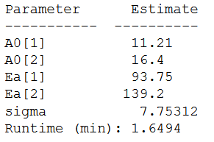

**CSTR MCMC estimation output example:**

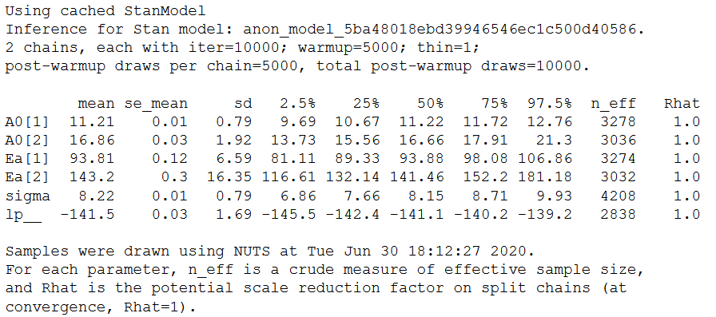

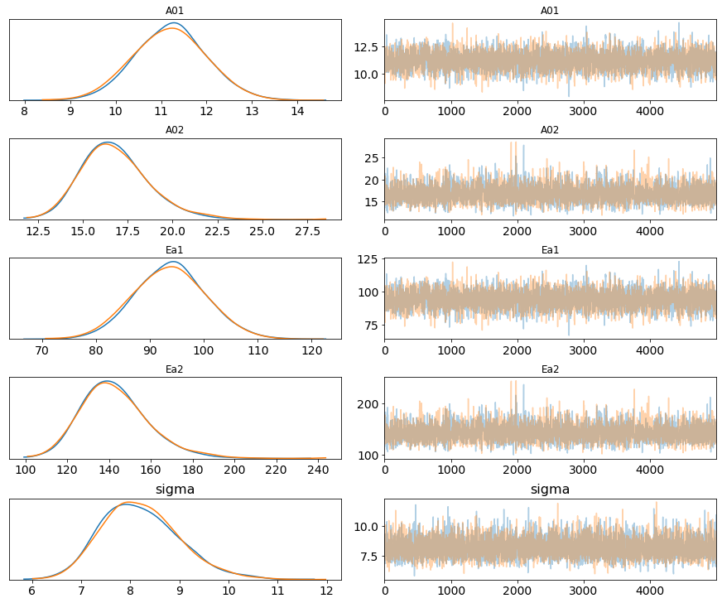

**CSTR VI estimation output example:**

